
Community Players of Salisbury, Inc.
P.O. BOX 2431 - SALISBURY, MARYLAND 21802 - 410-546-0099 FOUNDED 1938

Thursday, August 06, 2015

The Community Player's begin their 78th season with “The Addams Family”. A new Broadway musical that is certain to make your Halloween experience unforgettable. We continue with a four show season, offering two musicals productions and two straight productions. As always, we try to make it flexible enough to suit everybody’s choices and audience ratings are shown to alert you to content that may be unsuitable for younger audiences. As last year there are no Sunday performances at Wor-Wic Community College but we have added matinee performances to the Saturday performances to compensate for the loss. On-line order and payment options through PayPal will be available again this season. Credit/Debit card orders are also accepted by phone or at each performance. Please contact us if you have any questions.

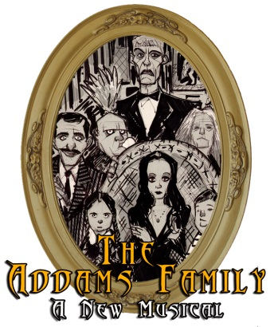
“THE ADDAMS FAMILY” (PG)
Book by Marshall Brickman and Rick Elice
Music & Lyrics by Andrew Lippa

Friday, October 30, 2015 8:00 PM
Saturday, October 31, 2015 8:00 PM
Sunday, November 1, 2015 2:00 PM

All performances at Wicomico High School Auditorium

This magnificently macabre new musical comedy comes to devilishly delightful life in THE ADDAMS FAMILY and it’s every father’s nightmare. Wednesday Addams, the ultimate princess of darkness, has grown up and fallen in love with a sweet, smart young man from a respectable family. A man her parents have never met. And if that weren’t upsetting enough, she confides in her father and begs him not to tell her mother. Now, Gomez Addams must do something he’s never done before — keep a secret from his beloved wife, Morticia. Everything will change for the whole family on the fateful night they host a dinner for Wednesday’s “normal” boyfriend and his parents.

Directed by Ken Johnson
Musical Director – Susan Robinson
Choreographer – Maria Demetriou

“STEEL MAGNOLIAS” (PG)
Written by: Robert Harling


The action is set in Truvy's beauty salon in Chinquapin, Louisiana, where all the ladies who are "anybody" come to have their hair done. Helped by her eager new assistant, Annelle, the outspoken, wise-cracking Truvy dispenses shampoos and free advice to the town's rich curmudgeon, Ouiser, an eccentric millionaire, Miss Clairee, who has a raging sweet tooth; and the local social leader, M'Lynn, whose daughter, Shelby, is about to marry a "good ole boy." Filled with hilarious repartee and not a few acerbic but humorously revealing verbal collisions, the play can go from high comedy to deep tragedy. Circumstances call for a sudden realization of their mortality and how that affects the others. It also draws on the underlying strength—and love—which give the play, and its characters, the special quality to make them truly touching, funny and marvelously amiable company in good times and bad.

All performances in Guerrieri Hall at Wor-Wic Community College

Friday, Jan. 29, 2016 – 8:00 pm Friday Feb. 5, 2016 – 8:00 pm
Saturday Jan. 30, 2016 – 2:00 pm Saturday Feb. 6, 2016 – 2:00 pm
Saturday Jan. 30, 2016 – 8:00 pm

Directed by Rusty Mumford
“MOON OVER BUFFALO" (PG)
by Ken Ludwig

In the madcap comedy tradition of Lend me a Tenor, the hilarious Moon Over Buffalo centers on George and Charlotte Hay, fading stars of the 1950's. At the moment, they’re playing Private Lives and Cyrano De Bergerac in rep in Buffalo, New York with 5 actors. On the brink of a disastrous split-up caused by George’s dalliance with a young ingénue, they receive word that they might just have one last shot at stardom: Frank Capra is coming to town to see their matinee, and if likes what he sees, he might cast them in his movie remake of The Scarlet Pimpernel. Unfortunately for George and Charlotte, everything that could go wrong does go wrong, abetted by a visit from their daughter’s clueless fiancé and hilarious uncertainty about which play they’re actually performing, caused by Charlotte’s deaf old stage-manager mother who hates every bone in George’s body.

All performances in Guerrieri Hall at Wor-Wic Community College

Friday, April 22, 2016 - 8:00 pm Friday, April 29, 2016 – 8:00 pm
Saturday, April 23, 2016 - 2:00 pm Saturday, April 30, 2016 – 2:00 pm
Saturday, April 23, 2016 - 8:00 pm

Directed by Sharon Benchoff

“MARY POPPINS" (G)
Based on books by P.L. Travers and the Disney Film

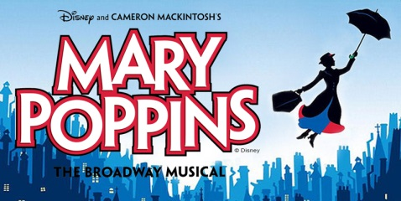
The jack-of-all trade, Bert, introduces us to England in 1910 and the troubled Banks family. Young Jane and Michael have sent many a nanny packing before Mary Poppins arrives on their doorstep. Using a combination of magic and common sense, she must teach the family how to value each other again. Mary Poppins takes the children on many magical and memorable adventures, but Jane and Michael aren't the only ones upon whom she has a profound effect. Even grown-ups can learn a lesson or two from the nanny who advises that "Anything can happen if you let it." Mary Poppins delighted Broadway audiences for over 2,500 performances and received nominations for nine Olivier and seven TONY Awards, including Best Musical.
All performances at Wicomico High School Auditorium
Friday, June 17, 2016 - 8:00 pm Friday, June 24, 2016 - 8:00 pm
Saturday, June 18, 2016 - 8:00 pm Saturday, June 25, 2016 - 2:00 pm
Sunday, June 19, 2016 - 2:00 pm

Directed by Joe Benamati
Musical Director – Susan Robinson
Choreographer – Laurie Birely

It is important that you designate which performance of all four shows you plan to attend, both for Season Tickets and Patrons. If you find you cannot make a performance you have chosen please contact us as soon as possible and we will exchange your tickets for a different performance as long as it isn’t sold out. Contact information. Ernie Matthews at 410-742-9186 or by sending e-mail to ( ernie29@comcast.net )


Enclosed please find a form which can be used to order SEASON TICKETS. Four great shows, one low price. As usual Senior Citizen, Student and Family discounts are provided. Group discounts are also available for 10 or more attending the same performance. Also private support for the Community Players has been great in the past and you can help maintain the high standards of our productions by becoming a PATRON. Patrons receive special seating at the Wicomico High School performances and are invited to attend a patron reception at the end of the season. A PATRON application form is included on the reverse of the Season Ticket order form.

Sincerely
Ernie Matthews for Community Players

P.S. - If you have any questions about Seasons Tickets or Patrons please call Ernie Matthews at 410-742-9186.

Also please visit our Webpages at ( www.communityplayersofsalisbury.org ). This site will have information about current productions and auditions. Please feel free to download any pictures you may wish to keep. Credit and Debit card purchases can be accessed from our Website or by calling 410-546-0099.

